Customer Bill of Exchange Reverse Contingent Liability

S.NO. : 02- FI-AR- 08

TRANSACTION CODE : F – 20

ACCESS PATH :SAP Easy Access Accounting Financial
Accounting Accounts Receivable Document Entry
Bill of Exchange Reverse Contingent Liability

We get “ Reverse Bill Liability – Header Data” Screen as under;

Required Fields:

Document Date : To be entered
G/L Account : Enter (11551 – Bill of Exchange- Domestic Reco. A/c)
Usage : To be set at “ Discounting”
Document No. : To enter the Bill of Exchange document number
Customer Account : To be entered
Posting date : Default

Document Type, Currency, Period & Company code appear as default after it has been entered for the first time.

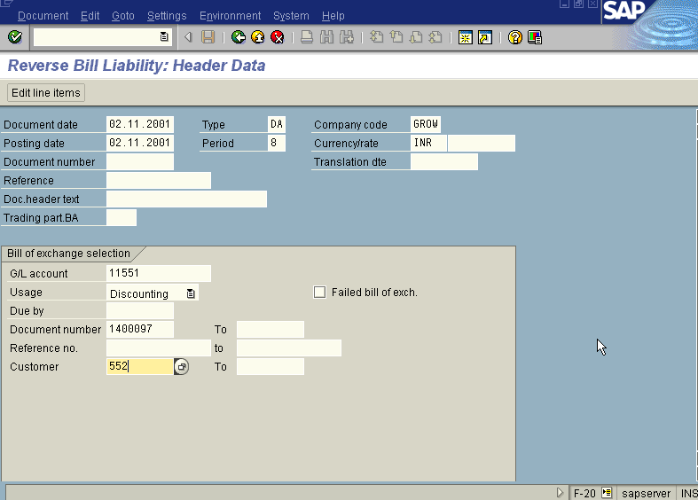
Press Enter Button

We get “ Reverse Bill Liability – Choose Postings” Screen as under

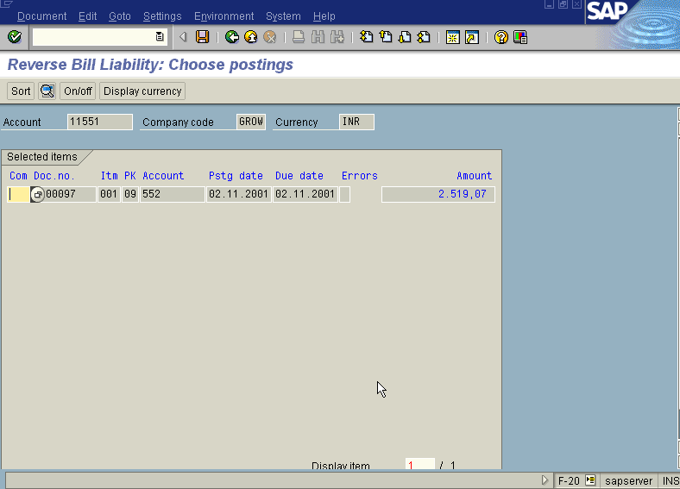

Press Save Button

The system displays the message as under

Take the note of the document number : 1600091.

To view the entries posted go to “Reverse Bill Liability – Header data” screen
And click Document Display or press Transaction Code FB03.

We get the Overview document screen with the entries as under

